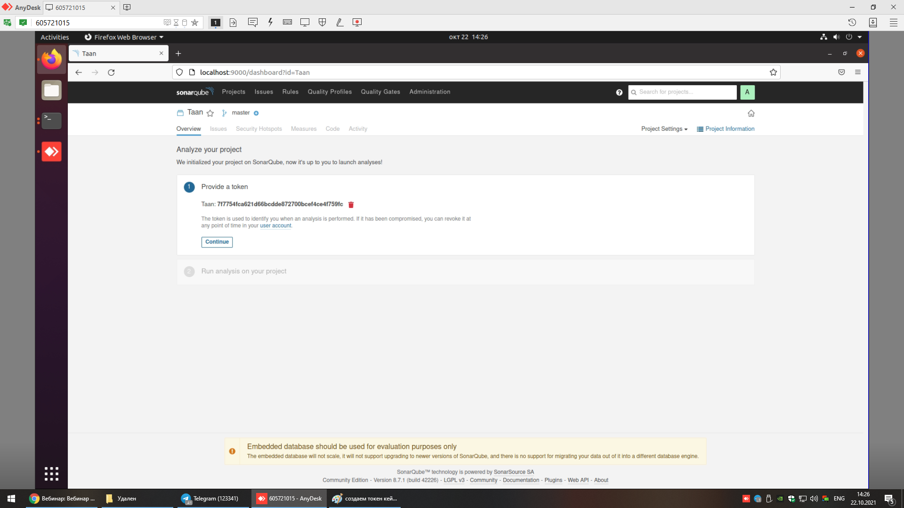

sonar-scanner \

-Dsonar.projectKey=go \

-Dsonar.sources=. \

-Dsonar.host.url=http://localhost:9000 \

-Dsonar.login=add0e56ebe74ba19fe21c1772d4d117e8abe2c64

dmitry@dmitry-VirtualBox:~/CI-CD/sonar-scanner-4.6.2.2472-linux/bin$ export PATH=$PATH:$(pwd)

#прописываем PATH

dmitry@dmitry-VirtualBox:~/CI-CD/sonar-scanner-4.6.2.2472-linux/bin$ $PATH

bash: /home/dmitry/.local/bin:/usr/local/sbin:/usr/local/bin:/usr/sbin:/usr/bin:/sbin:/bin:/usr/games:/usr/local/games:/snap/bin:/home/dmitry/CI-CD/sonar-scanner-4.6.2.2472-linux/bin: No such file or directory  
# смотрим что добавилась переменная в PATH

dmitry@dmitry-VirtualBox:~/CI-CD/sonar-scanner-4.6.2.2472-linux/bin$ sonar-scanner --version

INFO: Scanner configuration file: /home/dmitry/CI-CD/sonar-scanner-4.6.2.2472-linux/conf/sonar-scanner.properties

INFO: Project root configuration file: NONE

INFO: SonarScanner 4.6.2.2472

INFO: Java 11.0.11 AdoptOpenJDK (64-bit)

INFO: Linux 5.11.0-37-generic amd64

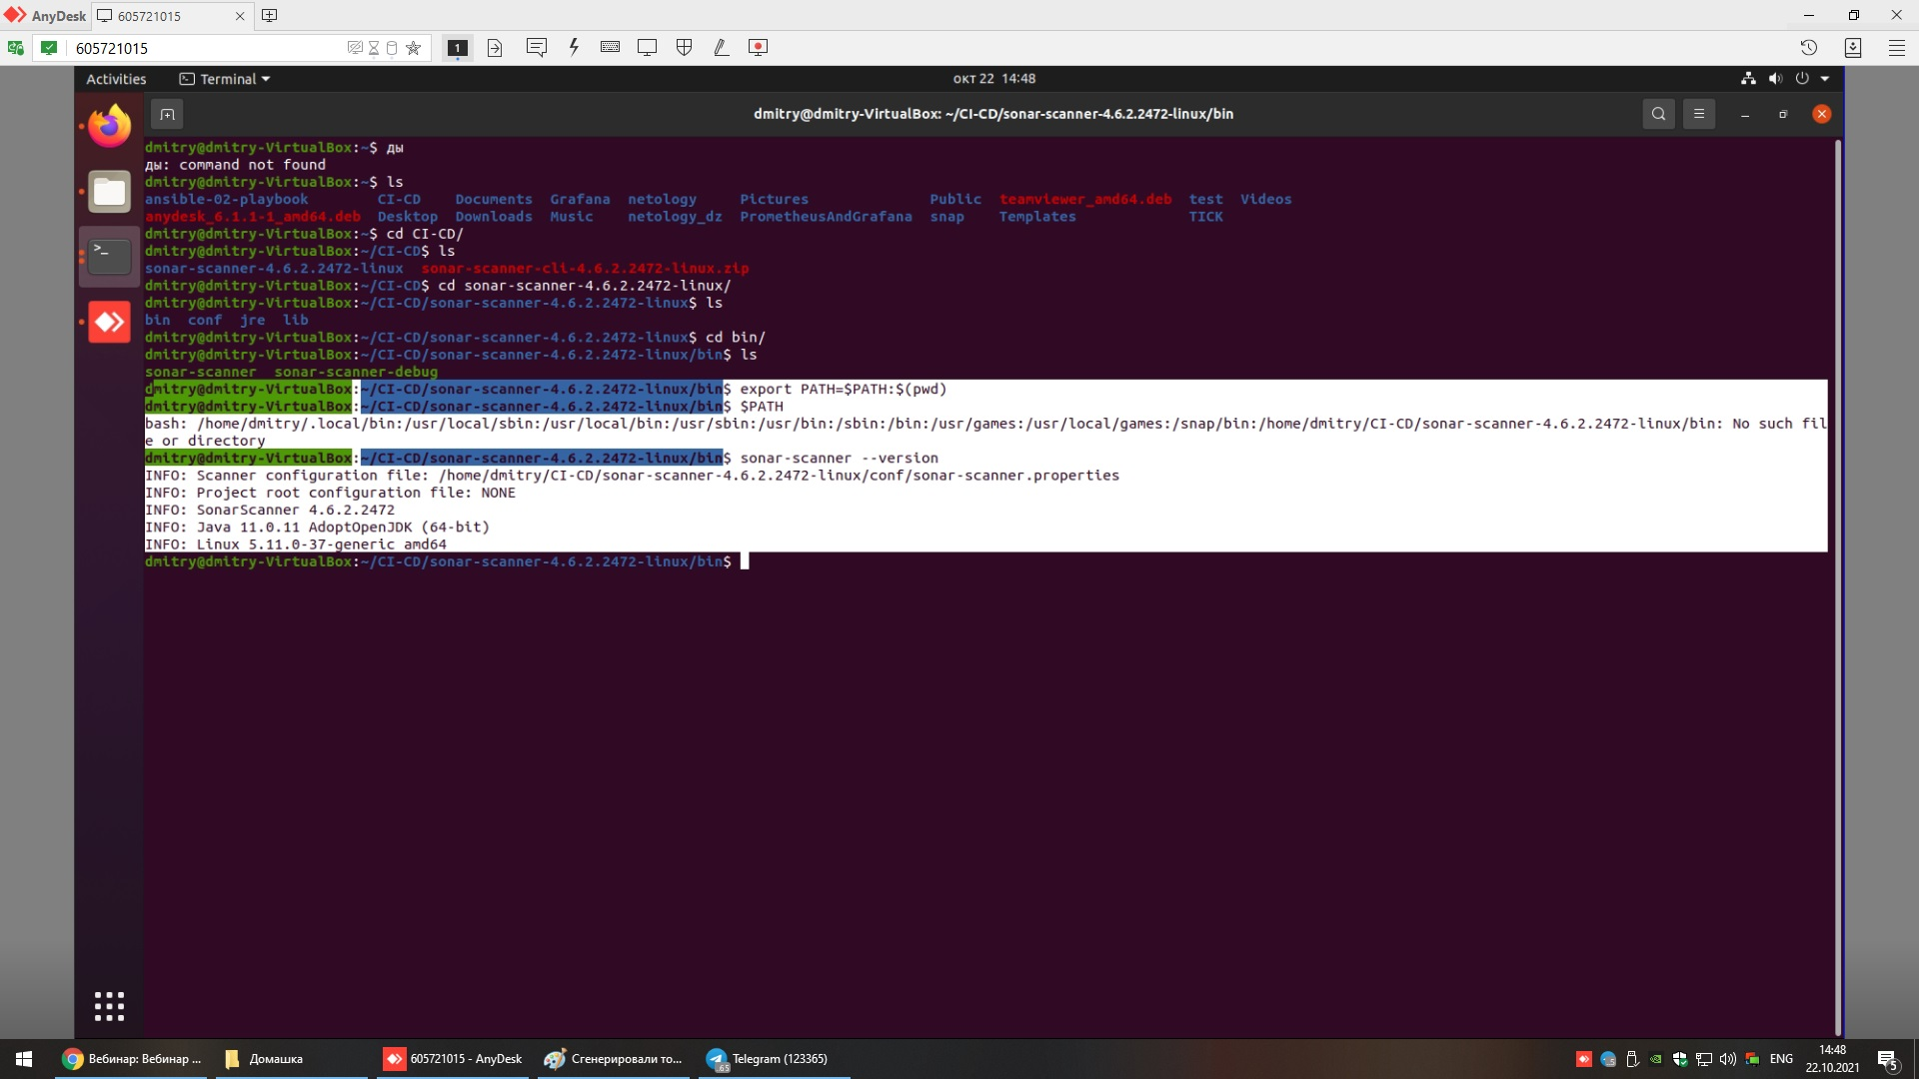

nexus   
Поднимаем контейнер   
  
dmitry@dmitry-VirtualBox:~/dz/09-ci-02-cicd/example$ docker run -d --name nexus -p 8081:8081 sonatype/nexus3:latest  
  
Смотрим логи контейнера  
dmitry@dmitry-VirtualBox:~/dz/09-ci-02-cicd/example$ docker logs -f nexus  
  
пароль от нексус

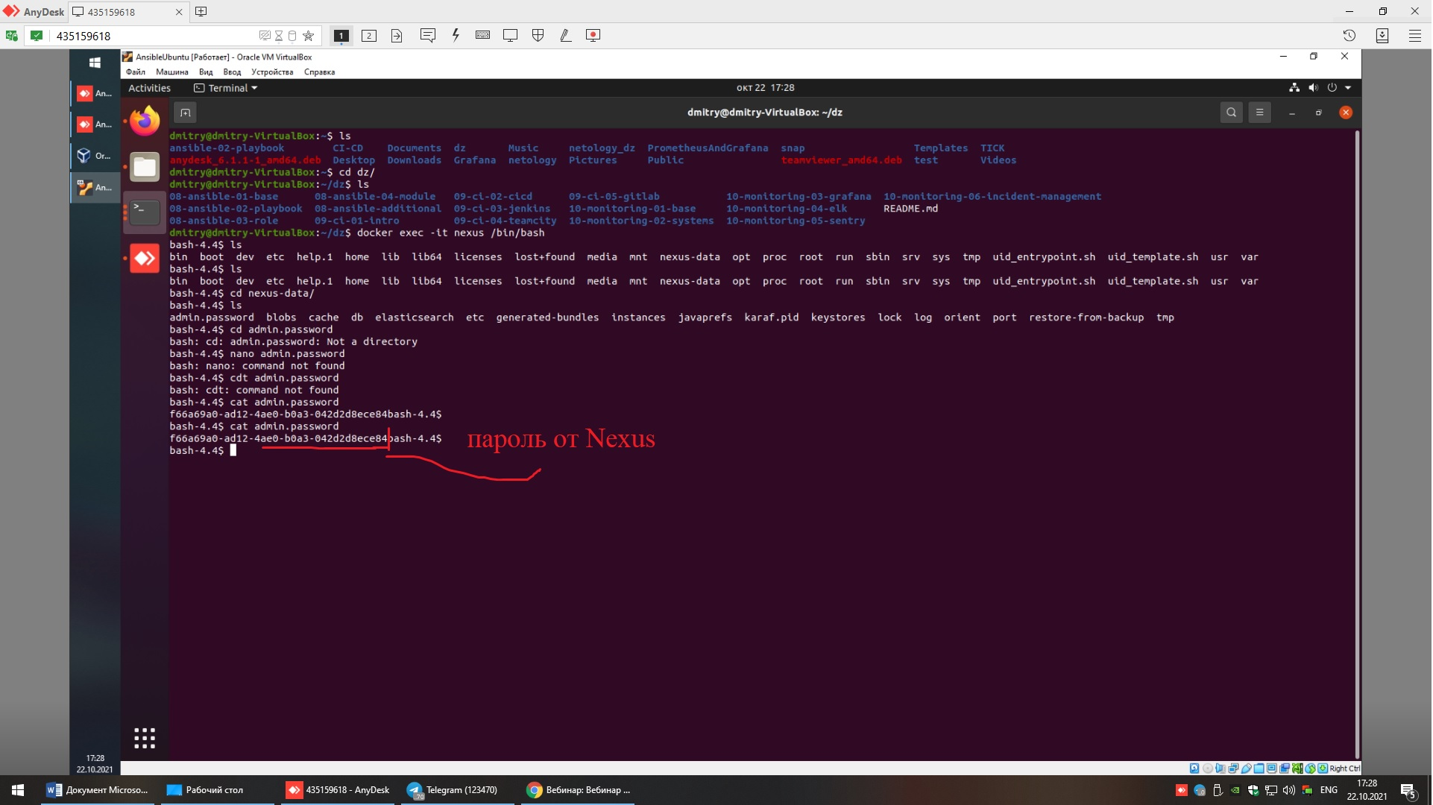

Логинимся

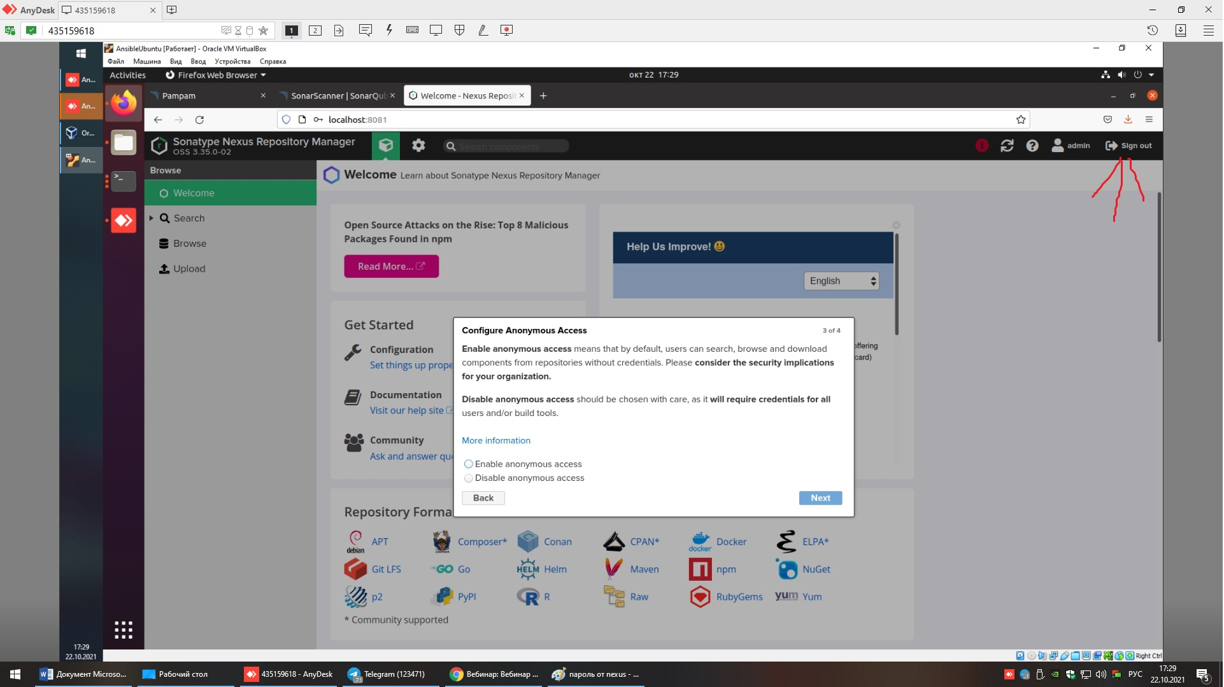

Исправил

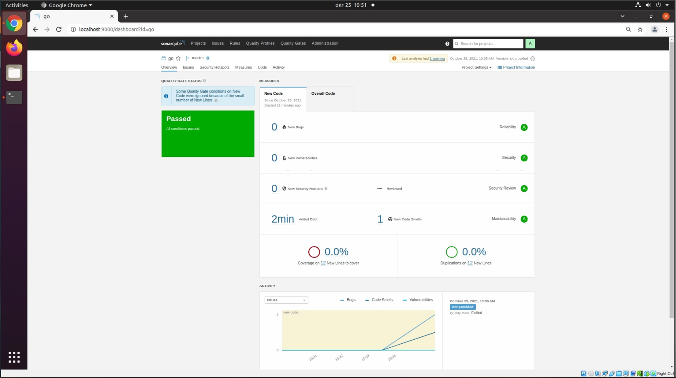

Maven

<project xmlns="http://maven.apache.org/POM/4.0.0" xmlns:xsi="http://www.w3.org/2001/XMLSchema-instance" xsi:schemaLocation="http://maven.apache.org/POM/4.0.0 http://maven.apache.org/xsd/maven-4.0.0.xsd">

<modelVersion>4.0.0</modelVersion>

<groupId>com.netology.app</groupId>

<artifactId>simple-app</artifactId>

<version>1.0-SNAPSHOT</version>

<repositories>

<repository>

<id>my-repo</id>

<name>maven-public</name>

<url>http://localhost:8081/repository/maven-public/</url>

</repository>

</repositories>

<dependencies>

<!-- <dependency>

<groupId>netology</groupId>

<artifactId>java</artifactId>

<version>8_282</version>

<classifier>distrib</classifier>

<type>tar.gz</type>

</dependency> -->

</dependencies>

</project>